

LIBRARY MANAGEMENT

SYSTEM

Mini project of Database Systems Lab (CSE 2262)

Submitted By:

Name: Moksha Deepak Kothari

Roll No: 4

Reg No: 210905017

Section: A

Department of Computer Science and Engineering

Manipal Institute of Technology, Manipal.

April 2023



DEPARTMENT OF COMPUTER SCIENCE & ENGINEERING

Manipal

09/05/2023

CERTIFICATE

This is to certify that the project titled Library Management System is a record of the bonafide work done by Moksha Deepak Kothari (Reg. No. 210905017) submitted in partial fulfilment of the requirements for the award of the Degree of Bachelor of Technology (B.Tech.) in COMPUTER SCIENCE & ENGINEERING of Manipal Institute of Technology, Manipal, Karnataka, (A Constituent Institute of Manipal Academy of Higher Education), during the academic year 2022-2023.

Name and Signature of Examiners:

1. Dr. Anup Bhat, Assistant Professor, CSE Dept.
2. Mr. Gowardhan Hegde, Assistant Professor Selection Grade, CSE Dept.

TABLE OF CONTENTS

Introduction………………………………………………………………….4

Abstract………………………………………………………………………..4

Problem Statement & Objectives……………………………………4

ER Diagram…………………………………………………………………...5

Relational Schema…………………………………………………………6

DDL Commands…………………………………………………………….6

Constraints……………………………………………………………………7

Methodology…………………………………………………………………8

Views……………………………………………………………………………9

Triggers………………………………………………………………………..9

Queries…………………………………………………………………….…10

Database connectivity….……………………………………………...11

UI Design (With sample data displayed) ……………………....12

Conclusion…………………………………………………………………..16

Limitations and Future Work……………………………………….16

References…………………………………………………………………..17

Introduction

The work of a Librarian can be quite tedious. They need to keep a track of all books the library holds, the publishers and authors of the books and all the borrowings and returns of books that occur daily. The accuracy of a librarian in record keeping is crucial for the proper management of books. Doing so manually can be inefficient, inaccurate, and inconsistent. The computerisation of data and record keeping can make the tracking and management of books in the library more fluid. It removes all the manual errors and reduces the probability of finding incompatible records. It also eliminates the issue of storing piles of record books and going through each page to look for a record.

Abstract

A certain library has several branches and wants to computerize its data. Multiple borrowers borrow books from the libraries. Each borrower can borrow several books at a time. A record of all these borrowings needs to be kept. A record of the authors and publishers of the books also needs to be kept.

An author can write several books but a book can only have one author. A publisher can publish several books, but a book can only be published by one publisher.

This project aims to create a database to store the data pertaining to the books as well as the borrowers of all the libraries. Along with this, overdues also need to be tracked and penalized accordingly.

Problem Statement & Objectives

Design and implement a book management service for a library with several branches. Include information about authors and publishers who have published the books the libraries carry along with information about books carried by each library. The database should be able to record information about the borrowers borrowing the books. The books should have a due date of return, and if not returned by then, the librarian should be able to see the amount the borrower owes for the overdue. The library charges two rupees per day of delay. Allow the user to see how many copies of a book each branch owns and how many copies are currently in the branch. The librarians should be able to add new books coming into the libraries.

For the branches, include information such as branch id, branch name and branch address.

For the publishers and authors, include their name, address, and contact details.

For the borrowers include information such as their id, name address and contact details.

For the borrowings, include information such as the borrower, date of borrowing, due date and ISBN of book borrowed.

For the books, include information such as their title, author, publisher, and copies owned by each branch.

Entity-Relationship Diagram

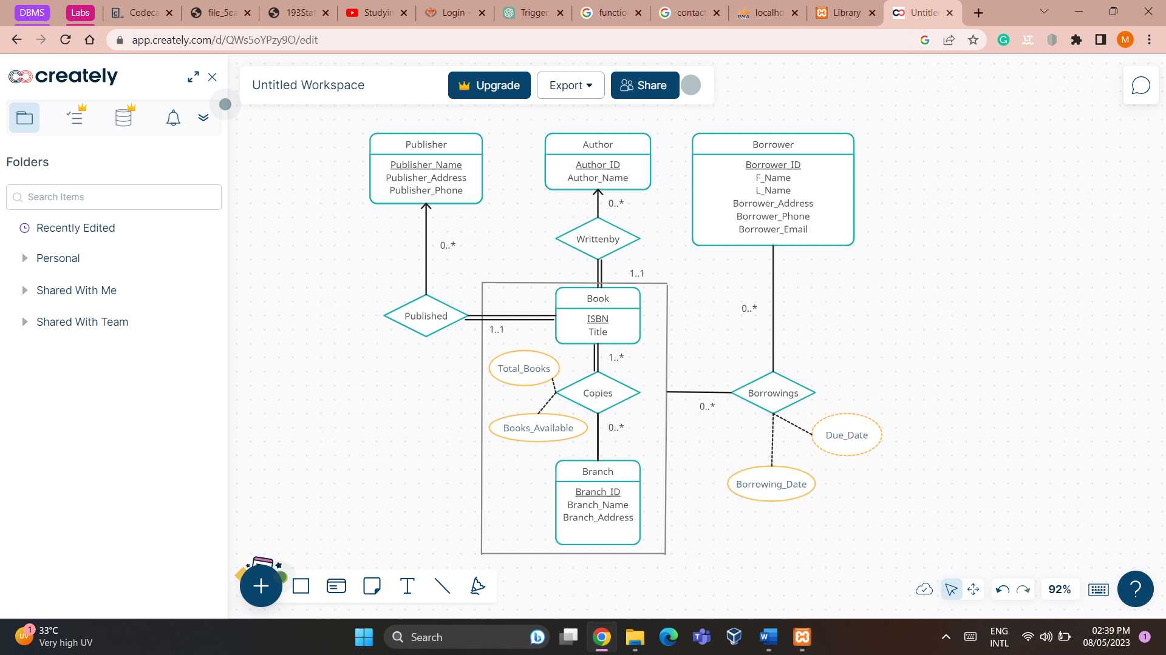

Relational Schema

DDL Commands

create table publisher( Publisher_Name varchar(30) primary key, Publisher_Address varchar(100) not null, Publisher_Phone numeric(10) not null);

create table author( Author_ID numeric(5) primary key, Author_Name varchar(100) not null);

create table book( ISBN numeric(13) primary key, Title varchar(30) not null, Publisher_Name varchar(30) not null);

[create](http://localhost/phpmyadmin/url.php?url=https://dev.mysql.com/doc/refman/8.0/en/create-table.html) [table](http://localhost/phpmyadmin/url.php?url=https://dev.mysql.com/doc/refman/8.0/en/create-table.html) writtenby(ISBN numeric(13), Author_ID numeric(5), primary key(ISBN, Author_ID));

create table borrower(Borrower_ID numeric(5) primary key, F_Name varchar(20) not null, L_Name varchar(20) not null, Borrower_Address varchar(100), Borrower_Phone numeric(10) not null, Borrower_Email varchar(20));

create table branch(Branch_ID varchar(5) primary key, Branch_Name varchar(20) not null, Branch_Address varchar(20) not null);

create table copies(Branch_ID varchar(5), ISBN numeric(13), Total_Copies numeric(3), Copies_Available numeric(3) ,primary key(Branch_ID, ISBN));

create table borrowings(Borrower_ID numeric(5), ISBN numeric(13), Branch_ID varchar(5), Borrowing_Date date, Due_Date date, primary key(Borrower_ID, ISBN, Branch_ID));

Integrity Constraints

alter table book add constraint pubnname_fk foreign key(Publisher_Name) references publisher(Publisher_Name);

alter table writtenby add constraint isbn_fk foreign key(ISBN) references book(ISBN);

alter table writtenby add constraint aut_fk foreign key(Author_ID) references author(Author_ID);

alter table copies add constraint cop_isbn_fk foreign key(ISBN) references book(ISBN);

alter table copies add constraint cop_branch_fk foreign key(Branch_ID) references branch(Branch_ID);

alter table borrowings add constraint bor_isbn_fk foreign key(ISBN) references book(ISBN);

alter table borrowings add constraint bor_id_fk foreign key(Borrower_ID) references borrower(Borrower_ID);

alter table borrowings add constraint bor_branch_fk foreign key(Branch_ID) references branch(Branch_ID);

alter table publisher add constraint pub_phone_check check (length(Publisher_Phone)=10);

alter table borrower add constraint bor_phone_check check (length(Borrower_Phone)=10);

alter table book add constraint isbn_check check(length(ISBN)=13);

**Participation Constraints**

1 book must have exactly 1 publisher, but a publisher may have published multiple books. The library may also not hold any books from the publisher.

1 book must have exactly one author, but an author may have authored multiple books. The library may also not hold any books from the author

A book may be at many branches, a branch can have many books, a branch may not have a particular book.

A borrower can borrow as many books as they would like (provided they do not borrow multiple copies of the same book), a book can be borrowed by multiple borrowers, and a book may not be borrowed by any borrower.

A borrower may not have any borrowings at a given point in time.

A borrower can only borrow 1 copy of a book from any of the branches.

**Methodology**

The tables that can be derived from the entity sets of the ER Diagram are:

* Publisher(Publisher_Name, Publisher_Address, Publisher_Phone)
* Author(Author_Id, Author_Name)
* Borrower(Borrower_ID, F_Name, L_Name, Borrower_Address, Borrower_Phone, Borrower_Email)
* Book(ISBN, Title)
* Branch(Branch_ID, Branch_Name, Branch_Address)

The tables that can be derived from relationship sets are:

* Writtenby(Author_ID, ISBN)

The current constraint is that the library contains books, such as novels, which have one author. However, the library might decide to add books such as textbooks in the future which can have multiple authors. Separating the two tables in the future would be tedious, hence it is taken as a separate schema.

* Copies(Branch_ID, ISBN, Total_Copies, Copies_Available)

Copies is a many-to-many relationship between book and branch, hence a separate schema is created for it.

* Borrowings(Borrower_ID, ISBN, Branch_ID, Borrowing_Date, Due_Date)

Borrowings is a relation between the copies relation and borrower table. It is taken as a relationship between the aggregation of books and branch tables and the borrower table. Since it is a many-to-many relationship, a separate schema is created for it.

Since Published is a one-to-many relationship, it does not require a separate schema. The primary key, Publisher_Name, can be added to the Book table, so the modified schema of books is Book(ISBN, Title, Publisher_Name)

The functional dependencies in the database are:

ISBN Title, Publisher_Name

Publisher_Name Publisher_Address, Publisher_Phone

Author_ID Author_Name

Borrower_ID F_Name, L_Name, Borrower_Address, Borrower_Phone,

Borrower_Email

Branch_ID Branch_Name, Branch_Address

ISBN Author_Name

ISBN, Borrower_ID Branch_ID

None of the constraints are violated by the schema. Hence the schema is in Boyce-Codd normal form.

Views

CREATE VIEW borr_with_amount AS SELECT Borrower_ID, ISBN, Branch_ID, Borrowing_Date, Due_Date, GREATEST(DATEDIFF(CURRENT_DATE,Due_Date) * 2,0) AS Amount_Due FROM borrowings GROUP BY Borrower_ID, ISBN, Branch_ID, Borrowing_Date, Due_Date;

Triggers

DELIMITER //

CREATE OR REPLACE TRIGGER `borrow` BEFORE INSERT ON `borrowings` FOR EACH ROW

BEGIN

DECLARE n INT;

SELECT Copies_Available INTO n FROM copies WHERE ISBN = NEW.ISBN AND Branch_ID = NEW.Branch_ID;

IF n > 0 THEN

UPDATE copies SET Copies_Available = Copies_Available - 1 WHERE ISBN = NEW.ISBN AND Branch_ID = NEW.Branch_ID;

END IF;

END//

DELIMITER ;

DELIMITER //

CREATE OR REPLACE TRIGGER `return`

BEFORE DELETE ON `borrowings` FOR EACH ROW

BEGIN

UPDATE copies SET Copies_Available = Copies_Available + 1 WHERE ISBN = OLD.ISBN AND Branch_ID = OLD.Branch_ID;

END//

DELIMITER ;

DELIMITER //

CREATE OR REPLACE TRIGGER `ret_date` AFTER INSERT ON `borrowings` FOR EACH ROW

BEGIN

UPDATE borrowings SET NEW.Due_Date = DATE_ADD(NEW.Borrowing_Date, INTERVAL 14 DAY) WHERE Borrower_ID=NEW.Borrower_ID and ISBN = NEW.ISBN AND Branch_ID = NEW.Branch_ID;

END//

DELIMITER ;

Queries

select * from copies natural join book;

select * from author where Author_ID=$authorid;

select * from publisher where Publisher_Name='$publishername';

select Branch_ID from branch where Branch_ID=’$branchid’;

insert into book values('$isbn','$title','$publishername');

insert into writtenby values('$isbn','$authorid');

insert into copies values('$branchid','$isbn','$num','$num');

select * from book where ISBN='$isbn';

select b.isbn, b.title, a.author_name, p.publisher_name, c.branch_id, c.total_copies, c.copies_available from book as b,writtenby as w, author as a, publisher as p, copies as c where b.publisher_name=p.publisher_name and b.isbn=w.isbn and a.author_id=w.author_id and b.isbn=c.isbn and b.isbn='$isbnentr';

select b.isbn, b.title, a.author_name, p.publisher_name, c.branch_id, c.total_copies, c.copies_available from book as b,writtenby as w, author as a, publisher as p, copies as c where b.publisher_name=p.publisher_name and b.isbn=w.isbn and a.author_id=w.author_id and b.isbn=c.isbn and b.title like '%$titleentr%';

select b.isbn, b.title, a.author_name, p.publisher_name, c.branch_id, c.total_copies, c.copies_available from book as b,writtenby as w, author as a, publisher as p, copies as c where b.publisher_name=p.publisher_name and b.isbn=w.isbn and a.author_id=w.author_id and b.isbn=c.isbn and a.author_name like '%$author%';

select b.isbn, b.title, a.author_name, p.publisher_name, c.branch_id, c.total_copies, c.copies_available from book as b,writtenby as w, author as a, publisher as p, copies as c where b.publisher_name=p.publisher_name and b.isbn=w.isbn and a.author_id=w.author_id and b.isbn=c.isbn and p.publisher_name like '%$pubentr%';

select * from borrower;

insert into borrower values($id,'$fame','$lname','$addr',$phone,'$email');

SELECT bor.Borrower_ID, bor.F_Name, bor.L_Name, bor.Borrower_Address, bor.Borrower_Phone, bor.Borrower_Email, b.ISBN, b.Due_Date, b.Amount_Due FROM borr_with_amount AS b, borrower as bor WHERE b.Borrower_ID=bor.Borrower_ID and bor.Borrower_ID='$borid';

SELECT bor.Borrower_ID, bor.F_Name, bor.L_Name, bor.Borrower_Address, bor.Borrower_Phone, bor.Borrower_Email, b.ISBN, b.Due_Date, b.Amount_Due FROM borr_with_amount AS b, borrower as bor WHERE b.Borrower_ID=bor.Borrower_ID and bor.F_Name like '%$borfname%';

SELECT bor.Borrower_ID, bor.F_Name, bor.L_Name, bor.Borrower_Address, bor.Borrower_Phone, bor.Borrower_Email, b.ISBN, b.Due_Date, b.Amount_Due FROM borr_with_amount AS b, borrower as bor WHERE b.Borrower_ID=bor.Borrower_ID and bor.L_Name like '%$borlname%';

SELECT bor.Borrower_ID, bor.F_Name, bor.L_Name, bor.Borrower_Address, bor.Borrower_Phone, bor.Borrower_Email, b.ISBN, b.Due_Date, b.Amount_Due FROM borr_with_amount AS b, borrower as bor WHERE b.Borrower_ID=bor.Borrower_ID and b.Amount_Due='$amtdue';

SELECT bor.Borrower_ID, bor.F_Name, bor.L_Name, bor.Borrower_Address, bor.Borrower_Phone, bor.Borrower_Email, b.ISBN, b.Due_Date, b.Amount_Due FROM borr_with_amount AS b, borrower as bor WHERE b.Borrower_ID=bor.Borrower_ID and b.Amount_Due>='$amtdue' ORDER BY Amount_Due;

select * from borr_with_amount order by Borrowing_Date desc;

insert into borrowings(Borrower_ID, ISBN, Branch_ID, Borrowing_Date) values($id,'$isbn','$branch','$date');

delete from borrowings where Borrower_ID='$id' and ISBN='$isbn' and Branch_ID='$branch';

select * from author;

insert into author values($authorid,'$authorname');

select * from publisher;

insert into publisher values('$pubname','$pubaddress',$pubphone);

select * from branch;

insert into branch values($brid,'$brname','$braddr');

**Database Connectivity**

I used a combination of HTML and PHP to create a user interface, which was then connected to my database to enable data retrieval and storage. This allowed me to create a dynamic and interactive web application that could easily interact with the database. The code snippet for database connectivity is:

$connection = mysqli_connect("localhost:4306", "root","");

$db = mysqli_select_db($connection,'library_db');

**UI Design**

The following are screenshots of the various pages that make up the user interface. They also display the sample data.

Homepage

Books Page

Displays information about all books in all the branches

Page to add a new book

Page to search for a book

Borrowers Page

Displays information about all borrowers

Page to add a new borrower

Page to search for a borrower

Borrowings Page

Displays information about all present borrowings

Page to issue a book

Page to return a book

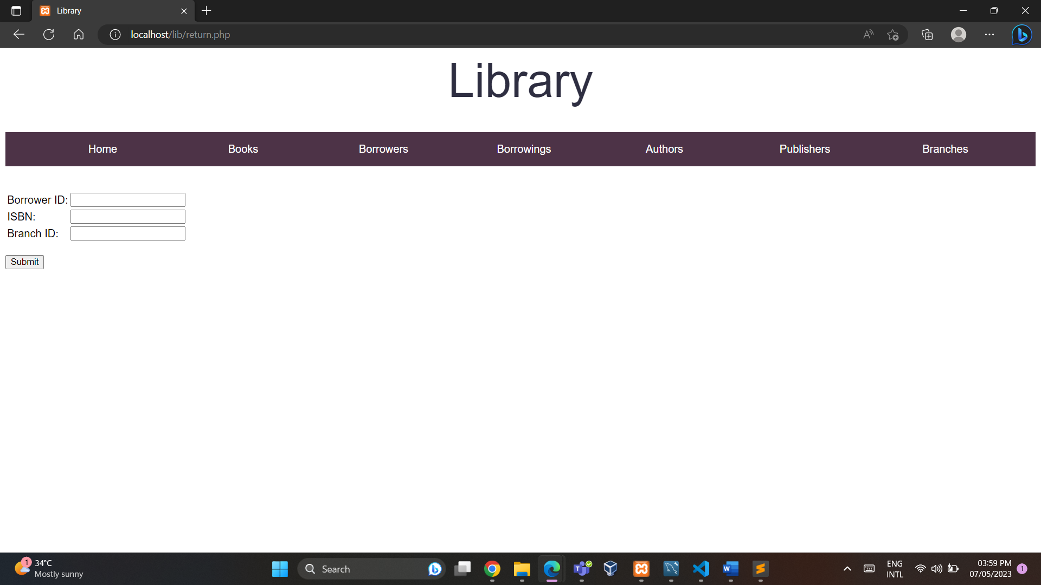

Authors Page

Displays information about all authors

Page to add a new author

Publishers Page

Displays information about all publishers

Page to add a new publisher

Branches Page

Displays information about all branches

Page to add a new branch

**Conclusion**

In conclusion, the manual management of books in a library can be a challenging task. It can lead to inconsistencies and errors in record-keeping. The implementation of a computerized book management service can help librarians keep track of books, borrowers, authors, publishers, and overdue books. The proposed project aims to design and implement a database that stores all the necessary information for efficient management of books in the library. It will allow librarians to add new books, keep track of borrowings and returns, and penalize borrowers for overdue books. By implementing such a system, librarians can efficiently manage the library, save time, and provide better services to the borrowers.

**Limitations And Future Work**

The project does not implement authentication and backup measures so both users and librarians currently have access to all data.

The project is also a simplified version of the real-life scenario. It does not allow users to search for books using quotes and the several categories such as genre and publication date. It only allows searching using publisher name, author name, book name and ISBN.

The database needs to be expanded further to have all these capabilities, making it more suitable for real-life use.

**References**

Database System Concepts by Abraham Silberschatz, Henry F. Korth, S. Sudarshan

<https://www.studocu.com/en-gb/document/university-of-east-london/advanced-software-engineering/library-management-system-final-report/10662691>

<https://www.w3schools.com/php/>

<https://www.w3schools.com/html/html_intro.asp>